EDA and Insights: Online Gaming Platform
  - EDA
- Dataset investigation
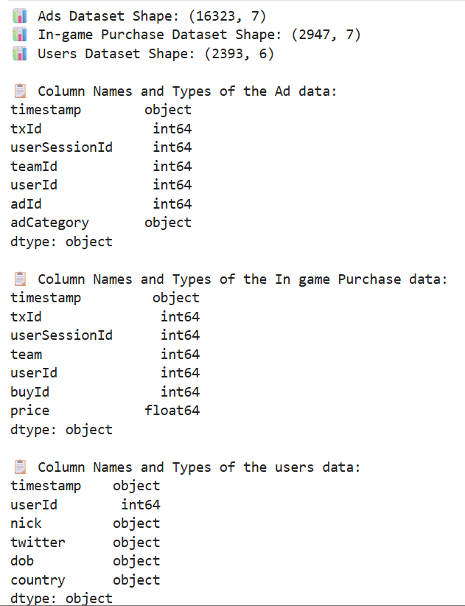

The shape of the 3 different datasets are as follows;
Ad data – 16323 rows and 7 columns
In game purchase data – 2947 rows and 7 columns
User dataset – 2393 rows and 6 columns

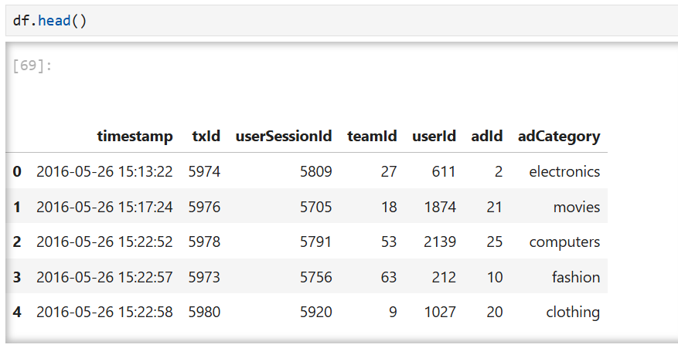
The top 5 rows of the Ad dataset:

Timesstamp: the time recorded in the database when the plyer clicked on an advert
txId: the unique ID generated for the click
userSessionId: the ID of the session when the user made the click
teamId: the current team the user belongs
userId: the unique ID for the player
adId: the unqiue ID for the adverts
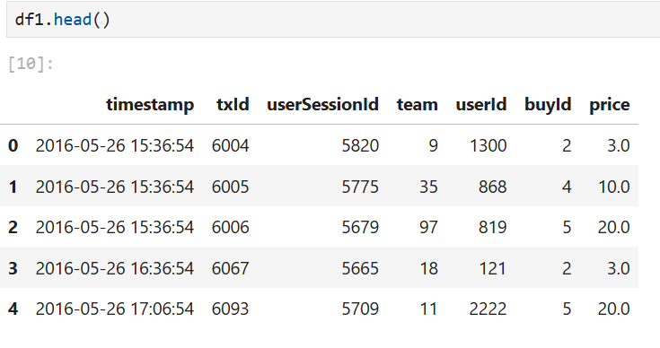
adCategory: the type of advert
buyId: the unique ID of item purchase
price: the price of the item purchased
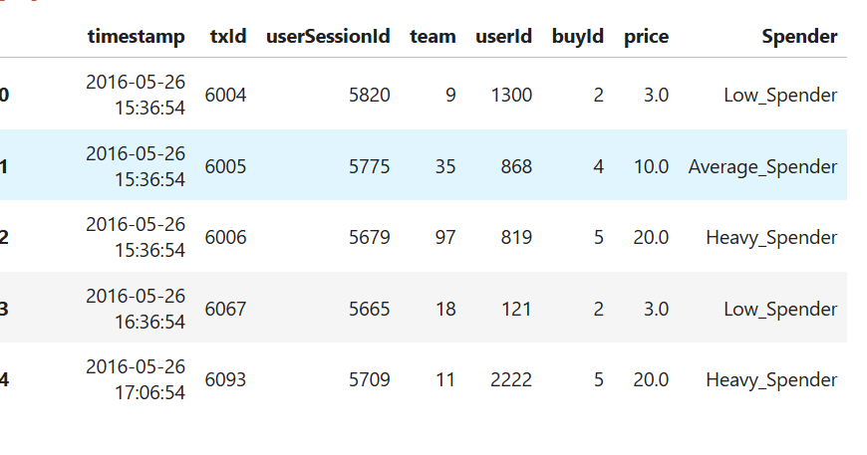
Spender: A new column created from categorising the price column into 3: Low_Spender when price < 5, Average_Spender when price 5<price<10 and Heavy_Spender when price>10.

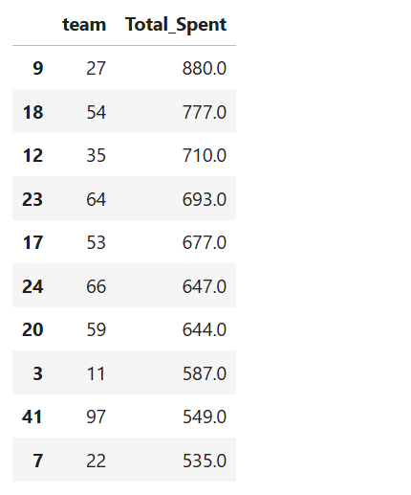
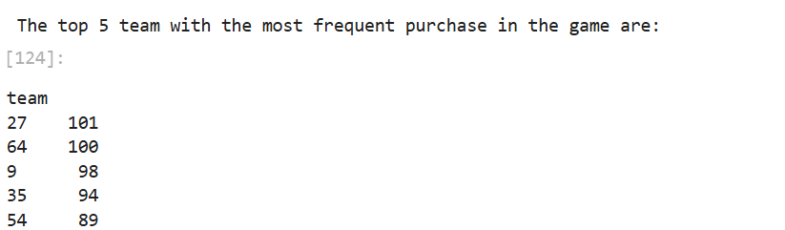
  - Insights
From the 2 figures above; Team 27 made the most frequent in-game purchase and also spent the most money on in-game purchase. However, team 64 made the second most in-game purchase but team 54 were the second most spenders on in-game purchase.

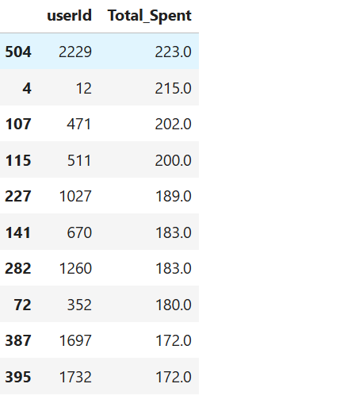
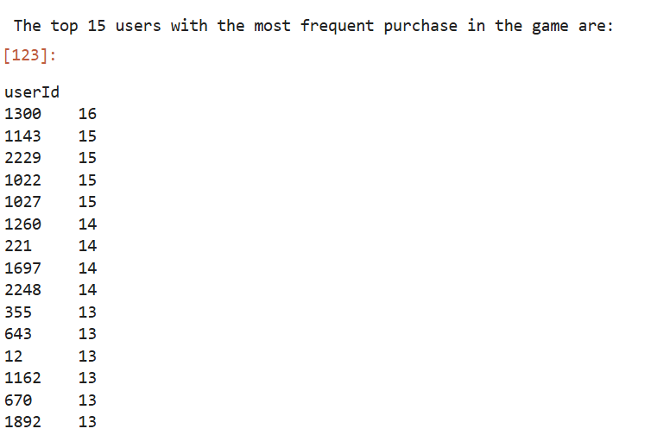
Just like the team insight explored earlier, the top frequent players making in-game purchases doesn’t reflect the top spending players.
UserID 1300 made 16 different in-game purchases but UserID 2229 spent most in the game.
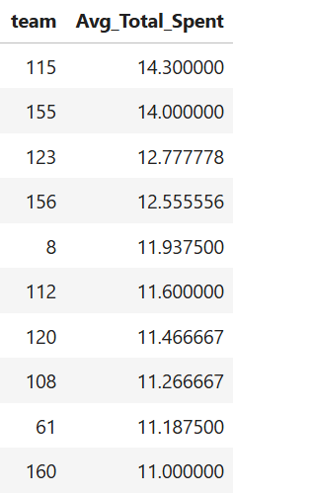
Also, on further investigation, the top spending team and the most frequent team spending are completely different from the average spenders.
Conclusively, we can therefore target all three of these findings to optimise in-game purchase.

